VM0048: Leakage Belt Delineation

Winrock Intl

2025-05-16

## Project Area & Jurisdictions

country = sf::read_sf("./data/AOI/liberia_boundary_national.shp") |>sf::st_transform(32629)  
counties = sf::st_read("./data/AOI/places_poly_county.shp") |>sf::st_transform(32629)

Reading layer `places_poly_county' from data source   
 `/Users/seamus/repos/rspb-redd-risk-new/data/AOI/places_poly_county.shp'   
 using driver `ESRI Shapefile'  
Simple feature collection with 16 features and 3 fields  
Geometry type: POLYGON  
Dimension: XY  
Bounding box: xmin: -11.50675 ymin: 4.353908 xmax: -7.367323 ymax: 8.551925  
Geodetic CRS: WGS 84

jurisdiction = counties |>dplyr::filter(name=="Grand Cape Mount County"|name=="Gharpolu County")  
jurisdiction$name = 'Grand Cape Mount & Gharpolu Counties'  
  
aoi = sf::read_sf("/Users/seamus/Library/CloudStorage/OneDrive-WinrockInternationalInstituteforAgriculturalDevelopment/20087 - RSPB Gola Feasibility/Deliverables/Spatial Data/AOI/Archive/ProjectArea_CF-Expansion_051525/updated_areas.shp") |>  
 sf::st_make_valid() |>  
 sf::st_transform("EPSG:32629") |>   
 sf::st_cast("MULTIPOLYGON") |> sf::st_as_sf() |> dplyr::select("Name")  
  
aoi$area_ha = round(as.numeric(sf::st_area(aoi) * 0.0001, 4))  
aoi |> sf::st_drop_geometry() |> janitor::adorn_totals()

Name area_ha  
 Lukasu 46997  
 Mbarma CF 44323  
 Lower Sokpo CF 14069  
 Upper Sokpo CF 10923  
 Zuie CF 36236  
 Gola Forest National Park 89042  
 Tonglay CF 19595  
 Norman CF 12349  
 Foya 104885  
 Kposo 30763  
 Gola Konneh CF 53102  
 Gola Konneh CF (ext. S) 10897  
 Gola Konneh CF (ext. N) 28590  
 Lower Sokpo CF (ext.) 4771  
 Maima CF (ext.) 13916  
 Zuie CF (ext.) 1495  
 Yangaya 5834  
 Koninga 31741  
 Lobarsu 16548  
 Bade 51367  
 No-mans land 39447  
 Lower Guma 14219  
 Central Guma 3850  
 Upper Guma 13771  
 Hassala 14570  
 Buluyeama 10021  
 Hembeh 46184  
 Total 769505

# Derive Leakage Area Belt

aoi_union = sf::st_transform(aoi, 32629) |> sf::st_union() |> sf::st_make_valid()  
leakage_buffer = sf::st_buffer(aoi_union, dist = 5500, endCapStyle="ROUND") |>  
 sf::st_as_sf()  
leakage_buffer = concaveman::concaveman(leakage_buffer, concavity=5) |>   
 sf::st_zm() |> sf::st_make_valid()  
leakage_belt_whole = sf::st_buffer(leakage_buffer, dist = 4500, endCapStyle="ROUND") |>  
 sf::st_make_valid()   
leakage_belt = sf::st_difference(leakage_belt_whole, st_union(st_combine(aoi_union)))  
leakage_belt$area_ha = round(as.numeric(sf::st_area(leakage_belt) * 0.0001, 4))   
leakage_belt = sf::st_intersection(country, leakage_belt)  
  
tmap::tmap_mode("plot")  
tmap::tm_shape(leakage_belt_whole) +   
 tmap::tm_polygons(col="orange",fill="orange",fill_alpha=0.3,lwd=1)+  
 #tmap::tm_add_legend(type="lines",col="orange",labels="Leakage Belt (10km)") +  
 tmap::tm_shape(aoi) + tmap::tm_borders(lwd=1, col="white") +  
 tmap::tm_basemap("Esri.WorldImagery")  
  
tmap::tm_shape(leakage_belt) +   
 tm_polygons(col="yellow",fill="yellow",fill_alpha=0.3)+  
 #tmap::tm_add_legend(type="lines",col="yellow",labels="Leakage Belt (10km)") +   
 tmap::tm_shape(aoi) + tmap::tm_borders(lwd=0.2, col="white") +   
 tmap::tm_text(text="Name", size=0.3, col="white") +  
 tmap::tm_basemap("Esri.WorldImagery")  
  
# save locally  
#sf::wt_write(leakage_belt, "OneDrive.../20087 - RSPB Gola Feasibility/Deliverables/  
# Spatial Data/LEAKAGE/Archive/LeakageBelt_10k-Radius_UnFiltered.zip")   
#sf::st_write(leakage_belt_whole, "OneDrive.../20087 - RSPB Gola Feasibility/Deliverables/Spatial Data/LEAKAGE/Archive/LeakageBelt_10k-Radius_UnFiltered-Whole.shp")

Reading layer `leakage_belt_10km_liberia_ext' from data source   
 `/Users/seamus/Library/CloudStorage/OneDrive-WinrockInternationalInstituteforAgriculturalDevelopment/20087 - RSPB Gola Feasibility/Deliverables/Spatial Data/LEAKAGE/Archive/LeakageBelt_10k-Radius_UnFiltered/leakage_belt_10km_liberia_ext.shp'   
 using driver `ESRI Shapefile'  
Simple feature collection with 1 feature and 3 fields  
Geometry type: MULTIPOLYGON  
Dimension: XY  
Bounding box: xmin: 245117.9 ymin: 776808.3 xmax: 406590.1 ymax: 908414.4  
Projected CRS: WGS 84 / UTM zone 29N

Reading layer `LeakageBelt_10k-Radius_UnFiltered-Whole' from data source   
 `/Users/seamus/Library/CloudStorage/OneDrive-WinrockInternationalInstituteforAgriculturalDevelopment/20087 - RSPB Gola Feasibility/Deliverables/Spatial Data/LEAKAGE/Archive/LeakageBelt_10k-Radius_UnFiltered-Whole.shp'   
 using driver `ESRI Shapefile'  
Simple feature collection with 1 feature and 1 field  
Geometry type: POLYGON  
Dimension: XY  
Bounding box: xmin: -11.31102 ymin: 7.024169 xmax: -9.847199 ymax: 8.24916  
Geodetic CRS: WGS 84

Simple feature collection with 1 feature and 4 fields  
Geometry type: MULTIPOLYGON  
Dimension: XY  
Bounding box: xmin: 245117.9 ymin: 776808.3 xmax: 406590.1 ymax: 908414.4  
Projected CRS: WGS 84 / UTM zone 29N  
 Name Shape_Leng Shape_Area geometry  
1 Leakage Belt 10km Radius 138549.7 469973056 MULTIPOLYGON (((245306.7 79...  
 area_ha  
1 298838

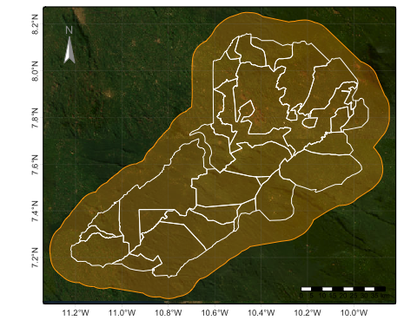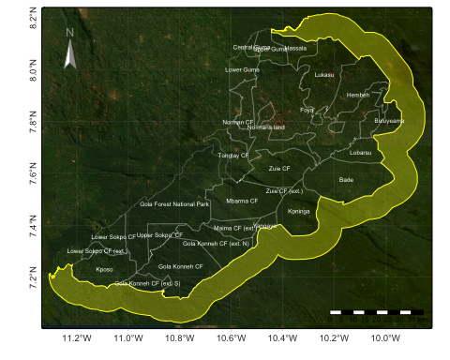

# Derive Leakage Area Masks

## Roads Mask

roads_one = sf::st_read("~/Library/CloudStorage/OneDrive-WinrockInternationalInstituteforAgriculturalDevelopment/20087 - RSPB Gola Feasibility/Deliverables/Spatial Data/ROADS/Archive/roads_simplified_one.shp")  
roads_two = sf::st_read("~/Library/CloudStorage/OneDrive-WinrockInternationalInstituteforAgriculturalDevelopment/20087 - RSPB Gola Feasibility/Deliverables/Spatial Data/ROADS/Archive/roads_simplified_two.shp")  
  
# we have simplify mask shapefiles and split them up to shorten computing   
# time & avoid crashing. See option for "harsh" simplification on line 163  
roads_one_simplified = roads_one |> sf::st_make_valid() |> sf::st_cast("MULTILINESTRING") |>   
 rmapshaper::ms_simplify(keep=0.5)  
roads_two_simplified = roads_two |> sf::st_make_valid() |> sf::st_cast("MULTILINESTRING") |>   
 rmapshaper::ms_simplify(keep=0.5)  
  
# bigger file needs more simplificaiotn  
roads_one_simplified_harsh = rmapshaper::ms_simplify(  
 roads_one_simplified, keep=0.01)   
  
# now apply buffer operation, but note this takes time. Its   
# advised processing inputs as much as possible before running  
roads_one_buffer = sf::st_buffer(  
 roads_one_simplified_harsh,   
 dist = 10000,   
 nQuadSegs = 5,  
 endCapStyle="ROUND",   
 joinStyle = "ROUND",  
 mitreLimit = 1,  
 singleSide = FALSE  
 )  
  
roads_two_buffer = sf::st_buffer(  
 roads_two_simplified,   
 dist = 10000,   
 nQuadSegs = 5,  
 endCapStyle="ROUND",   
 joinStyle = "ROUND",  
 mitreLimit = 1,  
 singleSide = FALSE  
 )  
  
# Combine, dissolve and cast to single feature  
roads_mask = sf::st_combine(roads_one_buffer, roads_two_buffer) |>  
 sf::st_union() |> sf::st_cast("POLYGON")  
  
# Visual check  
tmap::tmap_mode("plot")  
tmap::tm_shape(roads_mask) + tmap::tm_borders(lwd=0) +  
 tmap::tm_shape(roads_one_simplified_harsh) + tmap::tm_lines(lwd=2, col="red") +  
 tmap::tm_shape(roads_two_simplified) + tmap::tm_lines(lwd=2, col="green") +  
 tmap::tm_shape(roads_mask) + tmap::tm_borders(lwd=1, col="pink") +   
 tmap::tm_graticules(lines=T,labels.rot=c(0,90),lwd=0.2) +  
 tmap::tm_scale_bar(position = c("RIGHT", "BOTTOM"), text.size = .5) +   
 tmap::tm_compass(color.dark = "gray60", text.color = "gray60", position = c("left", "top"))  
  
# Save output to MASKS folder and purge memory  
#sf::st_write(roads_mask, "/Users/seamus/Library/CloudStorage/OneDrive-WinrockInternationalInstituteforAgriculturalDevelopment/20087 - RSPB Gola Feasibility/Deliverables/Spatial Data/MASKS/LeakageMask_Roads_10km-Buffer_051625.shp", delete_dsn=T)

Reading layer `roads_simplified_one' from data source   
 `/Users/seamus/Library/CloudStorage/OneDrive-WinrockInternationalInstituteforAgriculturalDevelopment/20087 - RSPB Gola Feasibility/Deliverables/Spatial Data/ROADS/Archive/roads_simplified_one.shp'   
 using driver `ESRI Shapefile'  
Simple feature collection with 842 features and 16 fields  
Geometry type: MULTILINESTRING  
Dimension: XY  
Bounding box: xmin: 237648.4 ymin: 761962.5 xmax: 400449.6 ymax: 923370.5  
Projected CRS: WGS 84 / UTM zone 29N

Reading layer `roads_simplified_two' from data source   
 `/Users/seamus/Library/CloudStorage/OneDrive-WinrockInternationalInstituteforAgriculturalDevelopment/20087 - RSPB Gola Feasibility/Deliverables/Spatial Data/ROADS/Archive/roads_simplified_two.shp'   
 using driver `ESRI Shapefile'  
Simple feature collection with 255 features and 16 fields  
Geometry type: MULTILINESTRING  
Dimension: XY  
Bounding box: xmin: 237648.4 ymin: 762265 xmax: 400334.4 ymax: 923370.5  
Projected CRS: WGS 84 / UTM zone 29N

Reading layer `Road_Mask_10km-Proximity_051625' from data source   
 `/Users/seamus/Library/CloudStorage/OneDrive-WinrockInternationalInstituteforAgriculturalDevelopment/20087 - RSPB Gola Feasibility/Deliverables/Spatial Data/MASK/Archive/LeakageMask_Roads_10km-Buffer_051625/Road_Mask_10km-Proximity_051625.shp'   
 using driver `ESRI Shapefile'  
Simple feature collection with 1 feature and 17 fields  
Geometry type: POLYGON  
Dimension: XY  
Bounding box: xmin: 227660.4 ymin: 752279.5 xmax: 410286 ymax: 933257.1  
Projected CRS: WGS 84 / UTM zone 29N

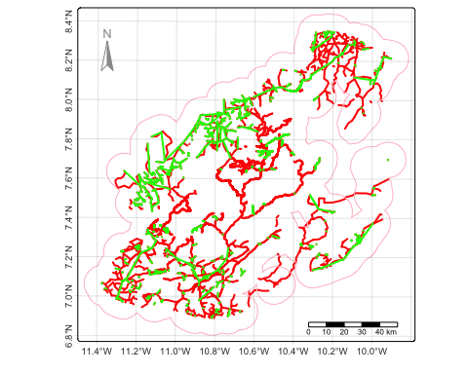

## Habitat Mask

# import inputs  
wetlands = terra::rast("/Users/seamus/Library/CloudStorage/OneDrive-WinrockInternationalInstituteforAgriculturalDevelopment/20087 - RSPB Gola Feasibility/Deliverables/Spatial Data/HABITAT/Wetlands/GLWD_EPSG32629.tif")  
protected_areas = sf::st_read("/Users/seamus/Library/CloudStorage/OneDrive-WinrockInternationalInstituteforAgriculturalDevelopment/20087 - RSPB Gola Feasibility/Deliverables/Spatial Data/HABITAT/Protected Areas/Archive/WDPA_Mar2025_Public_32629_GOLA.shp")

Reading layer `WDPA_Mar2025_Public_32629_GOLA' from data source   
 `/Users/seamus/Library/CloudStorage/OneDrive-WinrockInternationalInstituteforAgriculturalDevelopment/20087 - RSPB Gola Feasibility/Deliverables/Spatial Data/HABITAT/Protected Areas/Archive/WDPA_Mar2025_Public_32629_GOLA.shp'   
 using driver `ESRI Shapefile'  
Simple feature collection with 6 features and 30 fields  
Geometry type: POLYGON  
Dimension: XY  
Bounding box: xmin: 240189.7 ymin: 751293.6 xmax: 411102.7 ymax: 895314.1  
Projected CRS: WGS 84 / UTM zone 29N

leakage_belt_crop = sf::st_transform(sf::st_as_sf(leakage_belt_whole), 32629) |> terra::vect()  
wetlands = terra::crop(wetlands, leakage_belt_crop, mask=T)  
  
# tidy labeling  
code_dict_2 <- data.frame(  
 id = c(1, 4, 7, 10, 12, 14, 15, 18, 20, 21, 26, 31),  
 label = c(  
 "Freshwater lake", # 1  
 "Large river", # 4  
 "Small streams", # 7  
 "Riverine, regularly flooded, forested", # 10  
 "Riverine, seasonally flooded, forested", # 12  
 "Riverine, seasonally saturated, forested", # 14  
 "Riverine, seasonally saturated, non-forested", # 15  
 "Palustrine, seasonally saturated, forested", # 18  
 "Ephemeral, forested", # 20  
 "Ephemeral, non-forested", # 21  
 "Tropical peatland, forested", # 26  
 "Other coastal wetland" # 31  
 ))  
  
levels(wetlands) <- code_dict_2  
wetlands[wetlands == 0] <- NA  
  
# derive wetland mask  
wetlands_mask <- wetlands  
wetland_classes <- c(1, 4, 7, 10, 12, 14, 15, 18, 20, 21, 26, 31)  
terra::values(wetlands_mask) <- ifelse(terra::values(wetlands) %in% wetland_classes, 1, NA)  
  
# save locally for faster computing  
#raster::writeRaster(wetlands_mask, "/Users/seamus/Library/CloudStorage/OneDrive-WinrockInternationalInstituteforAgriculturalDevelopment/20087 - RSPB Gola Feasibility/Deliverables/Spatial Data/MASK/LeakageMask_Wetland-GLWD_051625.tif", overwrite=T)  
#sf::st_write(protected_areas, "/Users/seamus/Library/CloudStorage/OneDrive-WinrockInternationalInstituteforAgriculturalDevelopment/20087 - RSPB Gola Feasibility/Deliverables/Spatial Data/MASK/LeakageMask_ProtectedAreas_WDPA_051625.shp", delete_dsn=T)

## Slope Mask

# skipping these operations here (est. time 12 mins)  
DEM = terra::rast("/Users/seamus/Library/CloudStorage/OneDrive-WinrockInternationalInstituteforAgriculturalDevelopment/20087 - RSPB Gola Feasibility/Deliverables/Spatial Data/DEM/DEM_EPSG32629.tif")   
  
# derive slope percentage from degree   
slope_degrees = terra::terrain(DEM, v="slope", unit="degrees")  
slope_percent = tan(slope_degrees * (pi / 180)) * 100  
slope_percent = terra::clamp(slope_percent, 0, 100)   
slope_invalid = slope_percent > 10  
slope_invalid[slope_invalid == 0] <- NA  
slope_mask = terra::as.polygons(slope_invalid, dissolve=T)|>sf::st_as_sf()|>sf::st_union()  
  
# save locally & reload  
sf::st_write(slope_mask, "/Users/seamus/Library/CloudStorage/OneDrive-WinrockInternationalInstituteforAgriculturalDevelopment/20087 - RSPB Gola Feasibility/Deliverables/Spatial Data/MASK/LeakageMask_Slope10%-Invalid_051625.zip", delete_dsn=T)  
slope_mask = sf::st_read("/Users/seamus/Library/CloudStorage/OneDrive-WinrockInternationalInstituteforAgriculturalDevelopment/20087 - RSPB Gola Feasibility/Deliverables/Spatial Data/MASK/Archive/LeakageMask_Slope10%-Invalid_051625/slope_poly_simplified.shp")

## Visual Check

# Visual check  
tmap::tmap_mode("plot")  
tmap::tm_shape(roads_mask) + tmap::tm_borders(lwd=0) +  
 tmap::tm_shape(wetlands) + tm_raster(col.legend = tm_legend("Wetlands (GLWD")) +  
 tmap::tm_shape(leakage_belt) + tm_polygons(col="yellow",fill="yellow",fill_alpha=0.4, lwd=1.5)+   
 tmap::tm_shape(protected_areas) + tm_polygons(fill="ORIG_NAME", fill.legend = tm_legend("Protected Areas (WDPA)")) +  
 tmap::tm_shape(aoi) + tmap::tm_borders(lwd=1.5, col="red") +   
 tmap::tm_text(text="Name", size=0.3, col="black") +  
 tmap::tm_shape(roads_mask) + tmap::tm_borders(col="purple") +  
 tmap::tm_graticules(lines=T,labels.rot=c(0,90),lwd=0.2) +  
 tmap::tm_scalebar(position = c("RIGHT", "BOTTOM"), text.size = .5) +   
 tmap::tm_compass(color.dark = "gray60", text.color = "gray60", position = c("left", "top"))

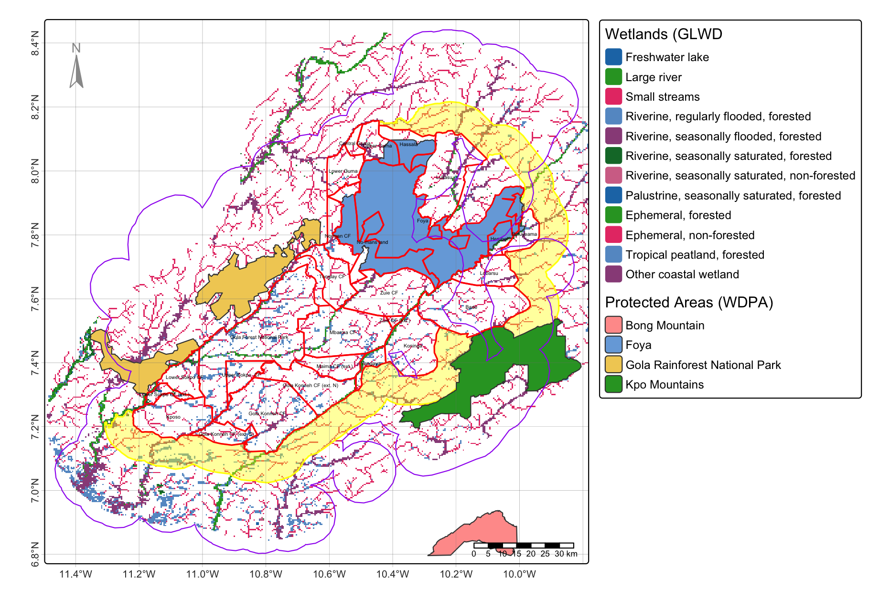

# Apply Leakage Area Masks

# clip  
roads_leakage_mask = sf::st_intersection(leakage_belt, roads_mask)  
slope_leakage_mask = sf::st_intersection(leakage_belt, slope_mask)  
wetlands_leakage_mask = sf::st_intersection(leakage_belt, wetlands_mask)  
protected_areas_leakage_mask = sf::st_intersection(leakage_belt, protected_areas)  
  
# merge. Btw actually makes better sense to keep these seperate.   
# They are easier to operate seperately due to their size and linework.  
leakage_mask_a = sf::st_union(roads_leakage, slope_leakage_mask)  
leakage_mask_b = sf::st_union(leakage_mask_a, wetlands_leakage_mask)  
leakage_mask_c = sf::st_union(leakage_mask_b, protected_areas_leakage_mask)  
  
# save  
sf::st_write(leakage_mask_c, "/Users/seamus/Library/CloudStorage/OneDrive-WinrockInternationalInstituteforAgriculturalDevelopment/20087 - RSPB Gola Feasibility/Deliverables/Spatial Data/LEAKAGE/Leakage Masks/", delete_dsn=T)

## Tally Features

road_count_whole = sf::st_intersection(road, leakage_belt_whole)  
road_count = sf::st_intersection(road, leakage_belt)  
road_length_whole = sum(sf::st_length(road_count_whole)) + sum(sf::st_length(road_count_whole))  
road_length = sum(sf::st_length(road_count)) + sum(sf::st_length(road_count))  
road_length_whole  
road_length  
  
waterways_count_whole = sf::st_intersection(waterways, leakage_belt_whole)  
waterways_count = sf::st_intersection(waterways, leakage_belt)  
waterways_length_whole = sum(sf::st_length(waterways_count_whole))  
waterways_length = sum(sf::st_length(waterways_count))  
waterways_length_whole  
waterways_length  
  
places_count_whole = sf::st_intersection(places, leakage_belt_whole)  
places_count = sf::st_intersection(places, leakage_belt)  
places_count_whole  
places_count